Child marriage a human rights violation, advocates say
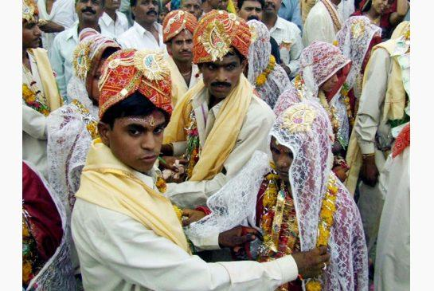
STRDEL / AFP/GETTY IMAGES/FILE PHOTO
Young women are married in a mass ceremony in 2006 in the Indian village of Funda, some 30 kilometres from Bhopal.
By: Jennifer Quinn News reporter, Published on Thu Mar 06 2014
It was about eight years ago that Shalini Nataraj saw the girl, and she still remembers her. Nataraj was visiting a village in India, and was struck by how young the girl looked — probably about 14. And she was holding a child. Her child.
Nataraj, director of advocacy and partnerships for the Global Fund for Women, a human rights organization, had worked in the region for years. She was used to seeing young mothers, but asked about this girl.
The villagers said she was 18. “And of course they would, because that’s the legal age of marriage in India,” Nataraj recalls. “But then I asked more about the family.”
It was a common story. The girl was one of about a half-dozen children, whose mother struggled to look after them. And like millions of other children around the world, she became a very young wife. Each year, the United Nations estimates that about 14 million girls are married before they are 18, and there are more child brides in India than anywhere else in the world.
“She stays with me,” Nataraj says. “By now, she probably has three or four more children. You see a lot of women who look like they’re in their 50s . . . and then you actually find out they are about 30.”
The issue of child marriage is part of a new Amnesty International campaign, launched ahead of International Women’s Day on Saturday. In it, the human rights group calls on governments to secure sexual and reproductive rights, saying the health and safety of women and girls is under threat.
“It is unbelievable that in the 21st century some countries are condoning child marriage and marital rape while others are outlawing abortion, sex outside marriage and same-sex sexual activity,” Salil Shetty, the group’s secretary general, said in a statement.
Canada has made the elimination of child marriage a foreign policy priority. Last year,Foreign Affairs Minister John Baird introduced a resolution at the United Nations on the issue and announced $5 million in funding to combat the practice.
Lynne Yelich, minister of state for foreign affairs and consular services, was recently in Geneva for the launch of a photo exhibit on child marriage; in a statement, she called child marriage “a violation of freedom and human rights and we, as citizens of the world, have an obligation to protect these children.”
The numbers are startling. UNICEF says that in the developing world, one in four adolescent girls between the age of 15 and 19 is married; in South Asia, that number is one in three.
And they are often married to much older men. In places such as Gambia and Sierra Leone, UNICEF survey data shows that more than half the teenage girls who are married are with men at least a decade older than they are; in places like Bangladesh, about a third of grooms married girls 10 years younger. (The statistics are based on demographic and health surveys and other research conducted by the United Nations.)
Social, cultural, religious and economic factors contribute to a society’s decision to allow child marriage, experts say. They can include tradition, belief that the girl will be protected from sexual assault or promiscuity, and especially — like the girl Nataraj still remembers in India — poverty.
Early marriage can have negative consequences for both the girl and her children: she will very likely be unable to continue her education or escape poverty; her health may be threatened by early and repeated pregnancies and childbirth; she can be exposed to HIV and domestic violence.
“As an ethical issue, as a human rights issue, those of us who want to see a better world need to deeply care about what is happening to young children, adolescent girls, who lack choice and voice, and what happens to them,” Nataraj says. “If we want to respect our own humanity, I think we really need to be concerned about what is happening, and the scale at which it is happening.”
A report by Human Rights Watch on child marriages — also released Thursday — focused on the sub-Saharan country of Malawi, where about half the female population is married by the time they are 18.
Called “I’ve Never Experienced Happiness,” the report calls on Malawi’s government to create an action plan to combat child marriage, develop and implement a national policy on adolescent reproductive health, and establish shelters for women escaping abusive situations.
“I feel very sad when I see small girls getting married,” a 28-year-old named Danira told Human Rights Watch researchers. She told them she was married when she was 13; her husband was 30.
“They don’t know the hard life that awaits them there,” she said. “I wish I had gone to school. Life could be better for me because I could get a job.”

